USER GUIDE

## ***Starting the Application***

* Click on the application icon to launch the application
* You will be prompted with a full-screen window with a map and a search asking for the address of your destination

## ***Using different Features***

1. Click on the application icon to launch the application
2. Enter the address of your destination in the input box and press Enter
3. If you want to know more information about the closest garage to you, click the bottom left button
4. If you want to find more garages nearby, click the button the bottom right
5. If you want to exit, click out of the app by pressing the home screen button

## ***Screenshots for Main Features of the System***

1. Open the application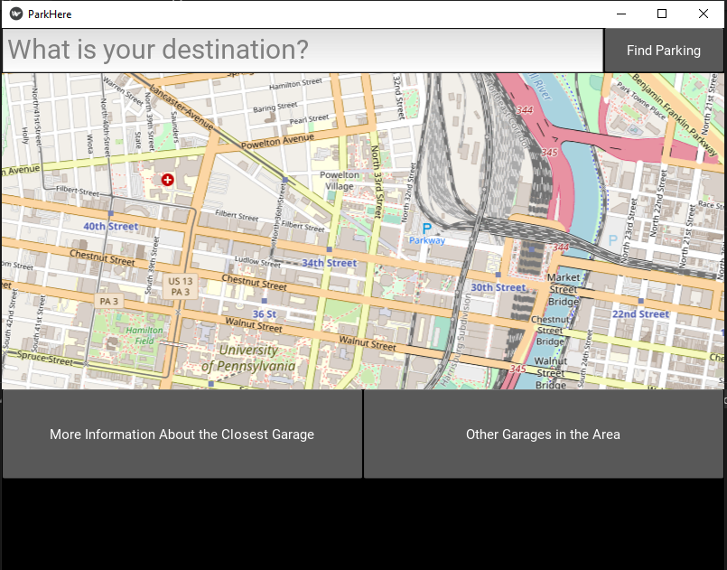
2. Enter your Destination

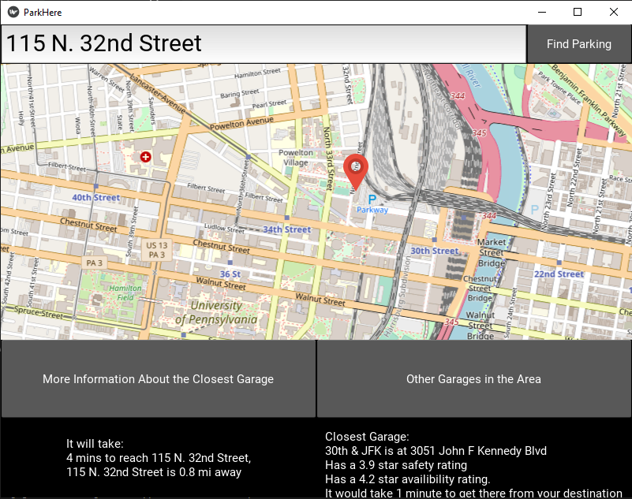

3. Ask for information about the nearest parking garage

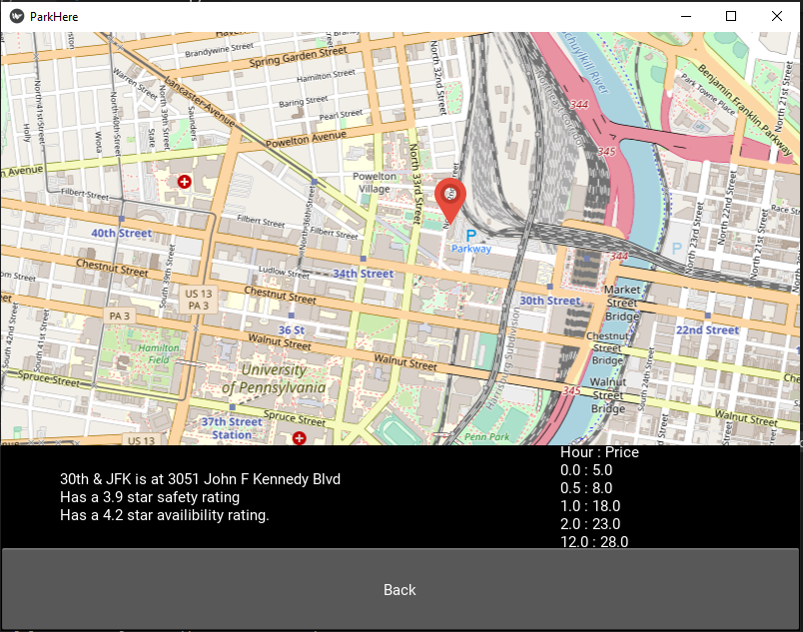

4. Ask for other nearby garages

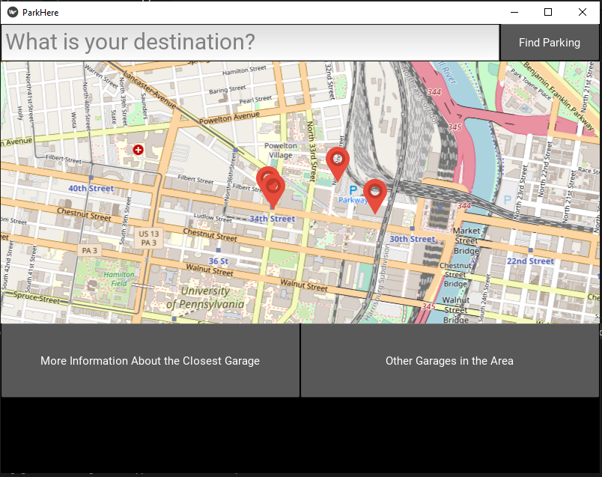

## ***Example Inputs and Outputs***

Input: 3675 Market Street

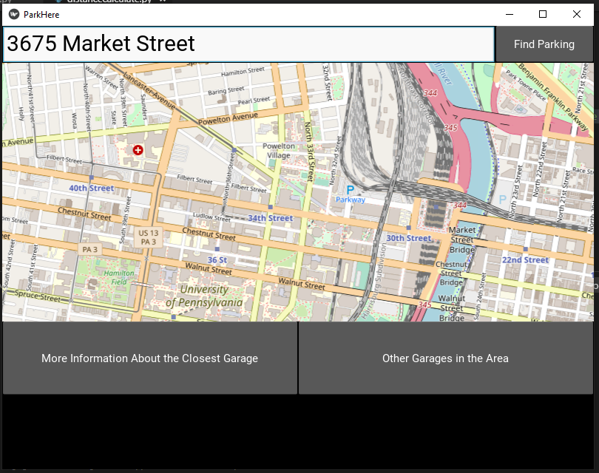

Output:

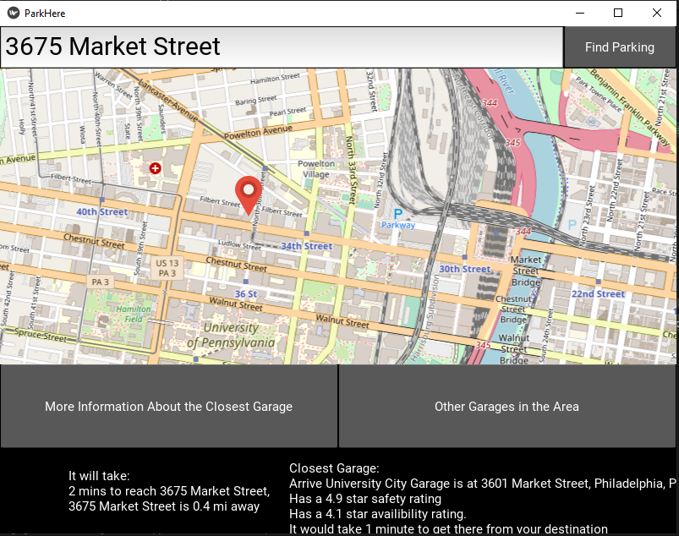

Input: 115 N. 32nd Street



Output:

